UNIT 4.4

RELATIONAL DATABASE SYSTEMS
TUTOR NAME: MS. IBTISAM MOGUL

SUBMITTED BY FATIMA EJAZ BARRI

Table of Contents
UNIT 4.4 1
RELATIONAL DATABASE SYSTEMS 1

- Database
The database is an organized collection of structured data to make it easily accessible, manageable and update. In simple words, you can say, a database in a place where the data is stored. The best analogy is the library. The library contains a huge collection of books of different genres, here the library is database and books are the data.


https://www.edureka.co/blog/what-is-a-database/?utm_source=quora&utm_medium=crosspost&utm_campaign=social-media-161019-vr

- Database management system (DBMS)
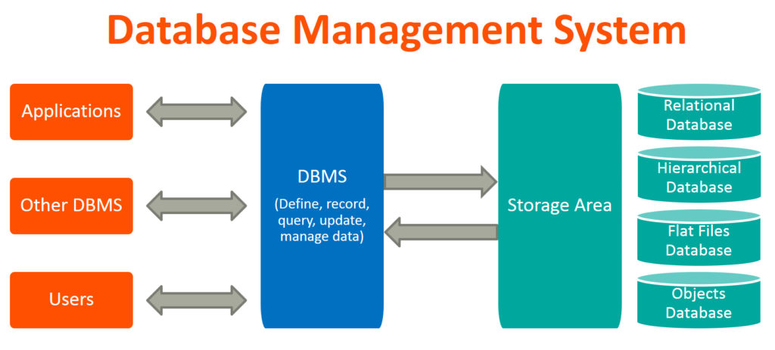
A Database Management System (DBMS) is a software that is used to manage the Database. It receives instruction from a Database Administrator (DBA) and accordingly instructs the system to make the corresponding changes. These commands are used to load, retrieve or modify existing data from the system. A database typically requires a comprehensive Database software program known as a Database Management System (DBMS). A DBMS serves as an interface between the database and its end-users or programs, allowing users to retrieve, update, and manage how the information is organized and optimized. A DBMS also facilitates oversight and control of databases, enabling a variety of administrative operations such as performance monitoring, tuning, and backup and recovery.
- Applications of DBMS
Banking system: For storing customer info, tracking day-to-day credit and debit transactions, generating bank statements etc. All this work has been done with the help of Database management systems.
Telecom: There is a database to keeps track of the information regarding calls made, network usage, customer details etc. Without the database systems, it is hard to maintain that huge amount of data that keeps updating every millisecond.
Airlines: To travel though airlines, we make early reservations; this reservation information along with flight schedule is stored in database.
Manufacturing: It is used for the management of supply chain and for tracking production of items. Inventories status in warehouses.
Educational: Database systems are frequently used in schools and colleges to store and retrieve the data regarding student details, staff details, course details, exam details, payroll data, attendance details, fees details etc. There is a hell lot amount of inter-related data that needs to be stored and retrieved in an efficient manner.
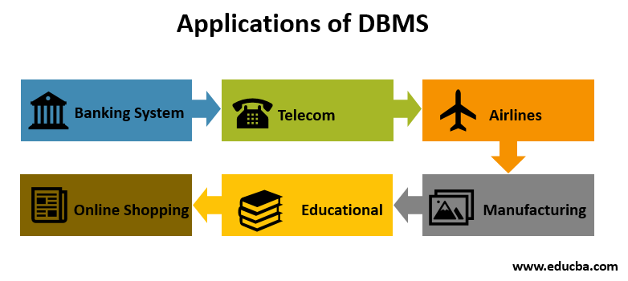
Online shopping: You must be aware of the online shopping websites such as Amazon, Flipkart etc. These sites store the product information, your addresses and preferences, credit details and provide you the relevant list of products based on your query. All this involves a Database management system.
https://beginnersbook.com/2015/04/database-applications/
- Advantages of DBMS
The Main advantages of DBMS are described below.
Controlling Data Redundancy:
In non-database systems, each application program has its own private files. In this case, the duplicated copies of the same data is created in many places. In DBMS, all data of an organization is integrated into a single database file. The data is recorded in only one place in the database and it is not duplicated.
Sharing of Data:
In DBMS, authorized users of the organization can share data. The database administrator manages the data and gives rights to users to access the data. Many users can be authorized to access the same piece of information simultaneously. The remote users can also share same data. Similarly, the data of same database can be shared between different application programs.
Data Consistency
By controlling the data redundancy, the data consistency is obtained. If a data item appears only once, any update to its value has to be performed only once and the updated value is immediately available to all users. If the DBMS has controlled redundancy, the database system enforces consistency.
Integration of Data
In Database management system, data in database is stored in tables. A single database contains multiple tables and relationships can be created between tables (or associated data entities). This makes easy to retrieve and update data.

Integration Constraints
Integrity constraints or consistency rules can be applied to database so that the correct data can be entered into database. The constraints may be applied to data item within a single record or the may be applied to relationships between records.

Data Security
Form is very important object of DBMS. You can create forms very easily and quickly in DBMS. Once a form is created, it can be used many times and it can be modified very easily. The created forms are also saved along with database and behave like a software component. A form provides very easy way (user-friendly) to enter data into database, edit data and display data from database. The non-technical users can also perform various operations on database through forms without going into technical details of a database.
Report Writers
Most of the DBMSs provide the report writer tools used to create reports. The users can create very easily and quickly. Once a report is created, it can be used may times and it can be modified very easily. The created reports are also saved along with database and behave like a software component.

Control Over Concurrency
In a computer file-based system, if two users are allowed to access data simultaneously, it is possible that they will interfere with each other. For example, if both users attempt to perform update operation on the same record, then one may overwrite the values recorded by the other. Most database management systems have sub-systems to control the concurrency so that transactions are always recorded with accuracy.

Backup and Recovery Procedures
In a computer file-based system, the user creates the backup of data regularly to protect the valuable data from damage due to failures to the computer system or application program. It is very time consuming method, if amount of data is large. Most of the DBMSs provide the 'backup and recovery' sub-systems that automatically create the backup of data and restore data if required.

Data Independence
The separation of data structure of database from the application program that uses the data is called data independence. In DBMS, you can easily change the structure of database without modifying the application program.
- Schema and Instance
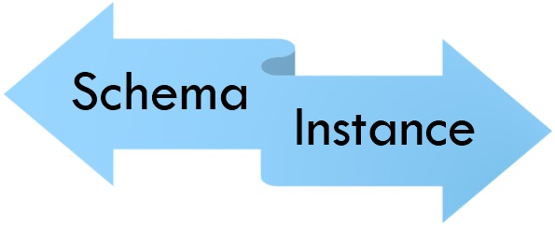

Schema:
It is the overall description of the database. Database administrator (DBA) is the person who has central control over the database (data as well as programs).schema is the logical view of database for database administrator.
There are two main kinds of database schema:
- Physical schema: it is the ability to modify the physical details without affecting the logical schema.it is provided by the mapping of DBMS & operating system.
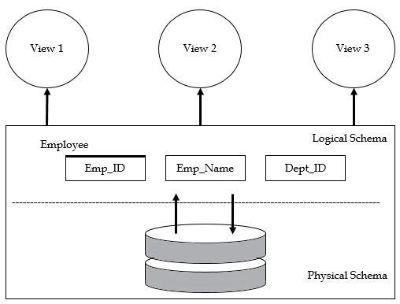
- Logical schema: it is the ability to modify the logical schema without causing applications programs to be rewritten. In addition, the changes in view level should not cause changes in schema.

Example of database:
Conceptual schema:
- Students (Sid: string, name: string, login: string, age: integer)
- Courses(cid: string, cname: string, credits: integer)
- Enrolled(Sid: string, cid:string,grade:string)
Physical schema:
- Relations stored as unordered files.
- Index on first column of students.
External schema (view):
- Course info (cid:strin,enrollment:integer)

